User Guide



Vidyo Meeting Room

Table of Contents:

**1** **Vidyo Meeting Login** 3

1.1 Vidyo Meeting Sign In Information: 3

**2** **Vidyo Meeting Room** 4

2.1 Vidyo Meeting Room details: 5

**3** **Logout Meeting:** 6

# **Vidyo Meeting Login**

When you access the Vidyo.io Text Chat Meeting URL, you are prompted to Join the Meeting.

## Vidyo Meeting Sign In Information:

The Vidyo.io Join Vidyo Meeting page will look similar to this:

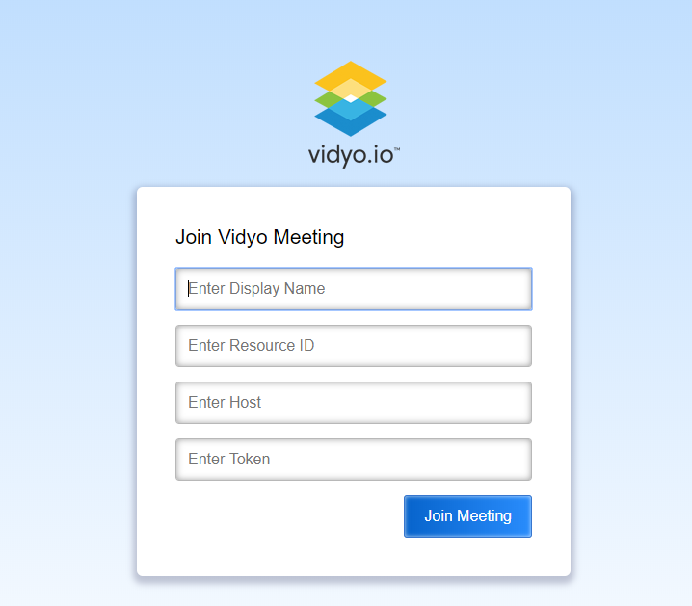

The Vidyo Meeting Join page allows the users to Join Meeting. It has four fields, the Display Name, Resource ID, Host and the Token. The inputs will be verified when you click the “Join Meeting” button and once the verification is complete, the user will proceed to the Meeting Room.

If the user enters invalid Display Name or Resource ID or Host or Token, appropriate error message is displayed to the user.

# **Vidyo Meeting Room**

Upon successful Join In to the Meeting, Meeting Room page is displayed to the user.

The Vidyo Meeting Room page will look similar to this:

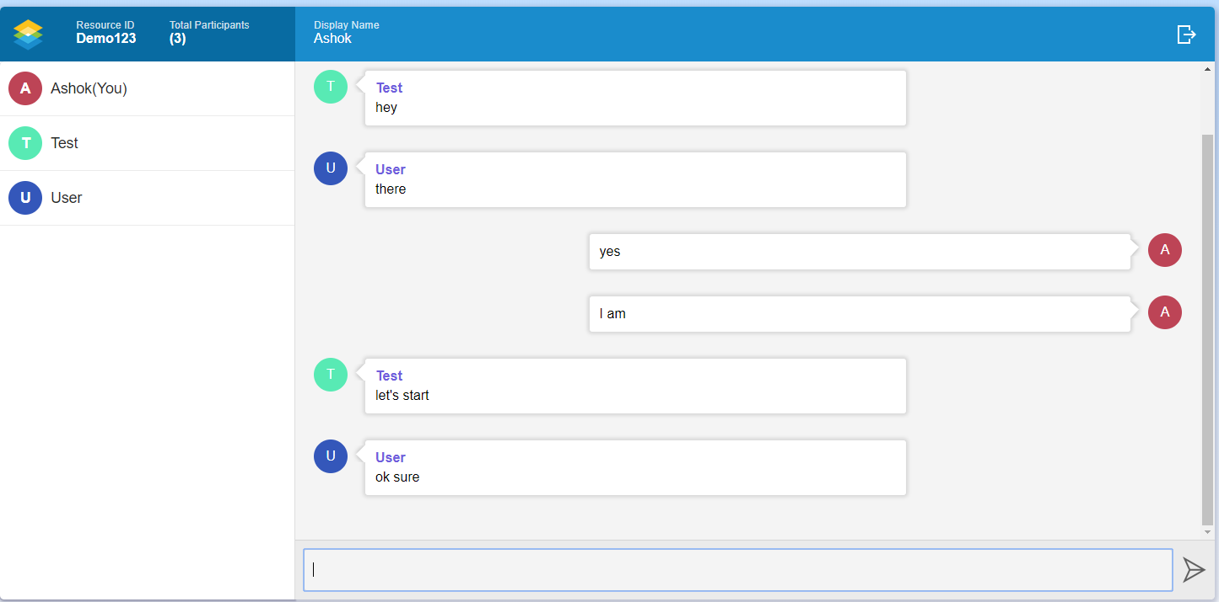

## Vidyo Meeting Room details:

Header section displays the Resource ID (currently joined Meeting), Total Participants (No of participants currently joined the Meeting) in the left side.

On the right side, Display Name (currently joined user’s Display Name) and Logout button.

Below the Header, on the left side, list of participants (Display Names) currently joined the meeting are displayed.

On the right side, messages entered are displayed.

Below the chat area, Text box is available which is used to enter any text to send. After entering message, User can send it either by clicking Send Button on screen or clicking Enter button on keyboard.

# **Logout Meeting:**

User can logout of the meeting by clicking Logout button displayed at the top right corner of the Meeting Room screen.

When user clicks Logout button, user is logged out of the current Meeting and returned to the Join Meeting Page.

